To replace SAFETY IO modules:

(Replacement module must be new. If not: see reference document listed below.)

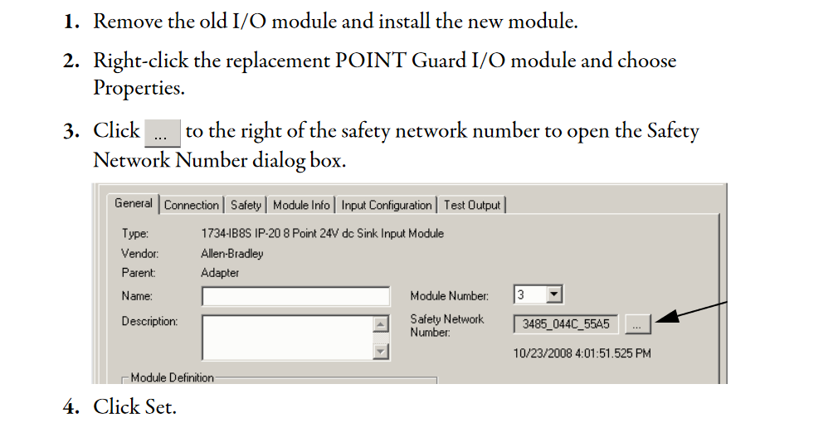

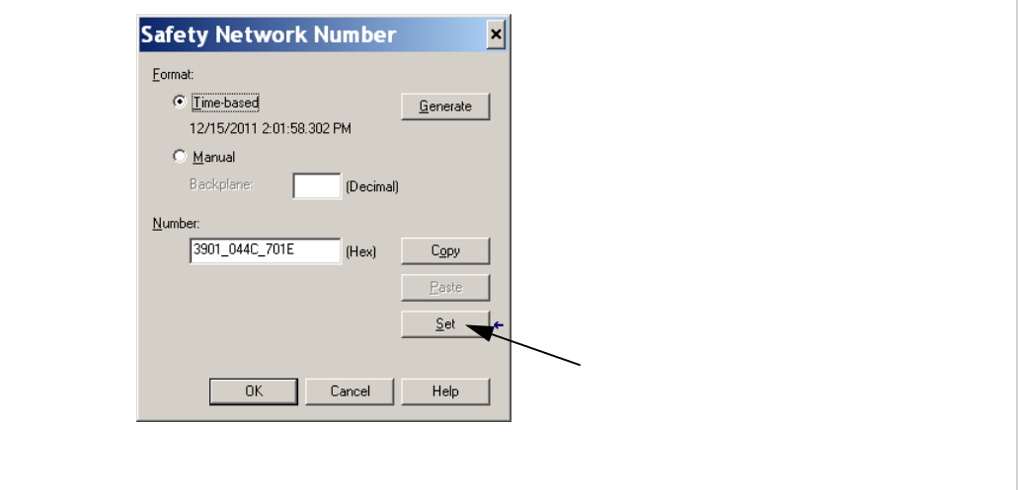

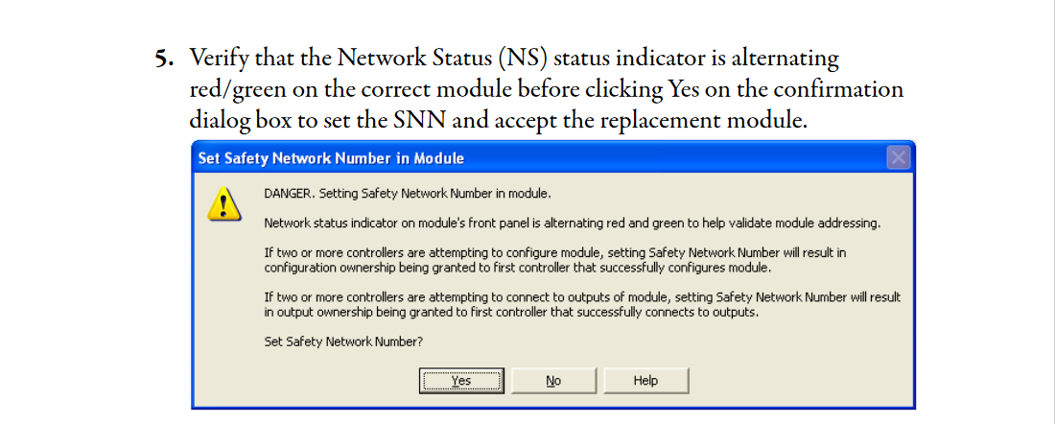

**Save a new copy of the PLC program with the new safety signature and archive the old.**

DONE!

REFERENCE: <https://literature.rockwellautomation.com/idc/groups/literature/documents/um/1756-um020_-en-p.pdf> Page 81-on